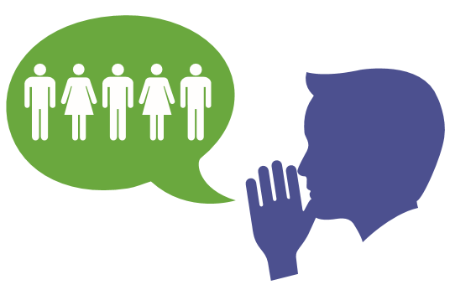

FACEBOOK POST DRAFTS

You can copy and paste these post directly on your Facebook page! We want to make it as simple as possible to reach out to your friends and family to encourage them to get screened for colon cancer!

Hey Guys I got screened for colon cancer recently! It wasn’t that bad and the nap was awesome! The reason I’m sharing is I want you to do the same when you are due! Talk to your doctor!
I had my colonoscopy the other day. Today when I got home from work my wife said, “The doctor called with your colonoscopy results. Good news – they found your head.” But seriously, I was screened for the most preventable cancer and I want to make sure you do the same! Go to KickingButt.org/Buddy for more info.

Friends, I want to share how I lost 5 lbs. in 1 day! I prepped for my colonoscopy! Now call your doctor and find out when you are due to be screened. For tips to make the prep taste better go to KickingButt.org/Buddy

There is no self-exam for colon cancer (thank goodness). Schedule your colonoscopy! I did and now I’m A VIP Buddy encouraging others to do the same! KickingButt.org/Buddy

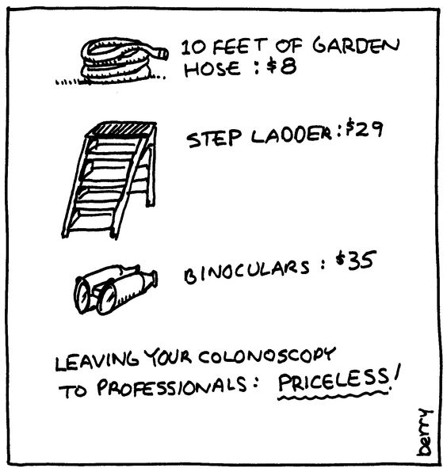

I chose priceless and you should too! Get screened! KickingButt.org/Buddy

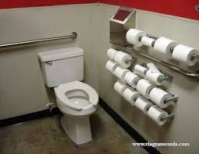

GOT T.P.?

