“Colon One” Golf Scramble
a Golf Outing supporting the
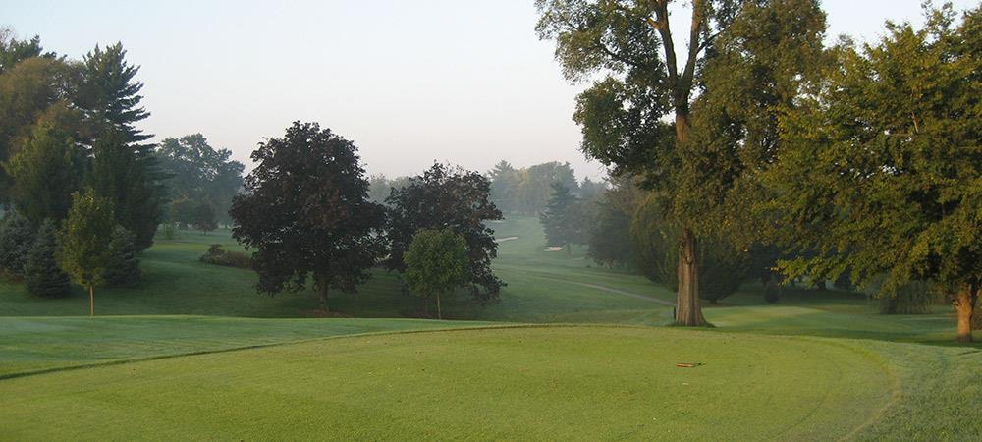
Oct. 19, 2015 * Audubon Country Club * Louisville, Ky.

The Colon Cancer Prevention Project
The Colon Cancer Prevention Project is the only non-profit in Kentucky that is focused solely on fighting the second deadliest cancer among men and women. Since the Project began, Kentucky’s colon cancer incidence rates has dropped 25%.

The Event
The event will have more than 100 participants – including survivors, physicians and other supporters from across the business community - and will include a meal, silent auction, and golf tournament.
All funds raised through the event will be used to making sure our neighbors get life-saving screenings and avoid this deadly killer.

Sponsorship Opportunities
We have wonderful marketing opportunities. The Colon Cancer Prevention Project has a wide reach across the state and region. Plus, your support saves lives!
Event Sponsor (Exclusive): $5,000
- Two foursomes
  - Each golfer receives: Greens and cart fees, lunch and then hors-d’oerves after golf; all beverages and snacks while you play; a golfer gift bag
- Prominently displayed “event sponsor” signage at the event
- Recognition during the speaking portion
- Company name and logo on all printed materials, including press releases and advertisements
- Company logo on event web site
- Company logo in two e-mail blasts each to more than 3,500 supporters
- The opportunity to have promotional items for all participants
- A hole sponsorship

Front Nine Sponsor (Exclusive): $2,500
- One foursome (please see event sponsor information for what golfers receive)
- Prominently displayed signage at Hole #1
- Company name or logo on all printed materials, including press releases and advertising
- Company logo on event web site
- Company logo in one e-mail blast to more than 3,500 supporters
- The opportunity to have promotional items for all participants
- A hole sponsorship

Back Nine Sponsor (Exclusive): $2,500
- One foursome (please see event sponsor information for what golfers receive)
- Prominently displayed signage at Hole #2
- Company name or logo on all printed materials, including press releases and advertising
- Company logo on event web site
- Company logo in one e-mail blast to more than 3,500 supporters
- The opportunity to have promotional items for all participants
- A hole sponsorship

Team Sponsor: $1,400
- (please see event sponsor information for what golfers receive)

Hole Sponsor: $250
- Company name or logo listed on signage at the hole
- The opportunity to have promotional items for all participants
- Company logo on event web site

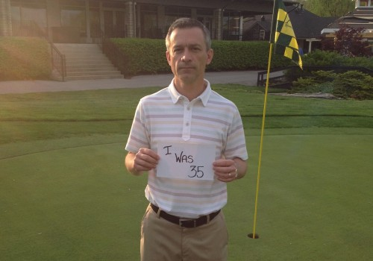
Audubon Country Club Head Golf Professional Eric Gilliland, a colon cancer survivor

For more information regarding the Colon Cancer Prevention Project or the “Colon One” Golf Scramble, contact Andrea Shepherd, Executive Director, at (502) 290-0288 or ashepherd@kickingbutt.org.
Colon Cancer Prevention Project
P.O. Box 4039
Louisville, Kentucky 40204
502.290.0288
www.coloncancerpreventionproject.org
facebook.com/coloncancerprevention

