#24hoursofkickingbutt
Tips & Templates
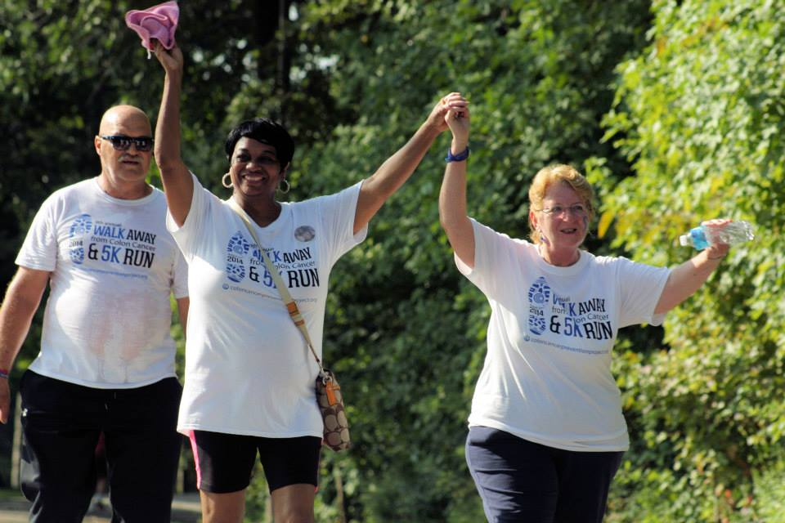
Tips for making it a successful day:
- Set a goal for how much you want to raise for your team, and make sure your team page is customized (see the toolkit e-mailed to you for more info on doing this. Want a toolkit? Contact ashepherd@kickingbutt.org)
- Use social media (Twitter, Facebook, Instagram, etc.) and email to share what you are doing. Don’t be afraid to post about it throughout the day – the rule of marketing is people need to see something 7-10 times before they take action!
- Share your personal story – why are you participating?
- Share photos and video related to why you care about this cause.
- Always link to your team page! You can find the page on our 5K web site.
- Post your progress throughout the day, recognize your supporters and ask them to share your team page!
- Share our social media sticker (if it’s not attached to this week’s email, it will be right before the big day!).
Sample social media posts:
My Kicking Butt 5K team is competing today, July 22, in the #24hoursofkickingbutt challenge! We have a goal of raising $(AMOUNT) that will be used to fight this second deadliest cancer. WILL YOU KICK BUTT? Every dollar makes a difference. You can support our team (TEAM NAME) – and register to join us! – through this link (PUT LINK TO YOUR TEAM PAGE).
Do you feel like kicking butt today? You can! My Kicking Butt 5K team has a goal of raising $XX in the next 24 hours as part of the #24hoursofkickingbutt challenge! Every dollar makes a difference and goes to fight this disease. Whether its $5 or $50, your support helps men and women avoid colon cancer through screening. Here’s our team page – (LINK). And be sure to talk with your doctor about getting screened for colon cancer!

I just KICKED BUTT! I donated to the “wave of giving” during today’s #24hoursofkickingbutt. Join me! (and the link).
Sample e-mail:
On Saturday, Aug. 22, I am participating in a 5K that raises funds to fight colon cancer – the Kicking Butt 5K. I signed up for this event (INSERT PERSONAL REASON HERE).
I am part of team (INSERT TEAM NAME HERE and add the link to your page), and we have a goal of raising (INSERT AMOUNT HERE), all of which will be used to get people screened for colon cancer and stop this disease!
You can help make a difference! All day on July 22, my team is competing in a challenge called #24hoursofkickingbutt. We hope to reach our team goal during this day, and also to recruit (INSERT NUMBER) team members. The top teams will be recognized at the 5K and in the Colon Cancer Prevention Project’s newsletters, among other things. There will also be loads of prizes for donors and registrants throughout the day (check out the Kicking Butt 5K Event page for more info that day)
Here’s how you can support us during July 22’s #24hoursofkickingbutt:
- Go to my team page: (INSERT LINK)
- Make a donation (and if you are free that day – register, too!)
- Share this with your friends!
Thank you for your support! And please remember, colon cancer is highly preventable with screening. Talk with your doctor about the right time for you to be screened (age 50 for average risk people). More information is available on the Colon Cancer Prevention Project’s web site, KickingButt.org.
Sincerely,
(YOUR NAME)

